**PIZZA SALES DATA ANALYSIS PROJECT**

### **Project Overview:**

Analysing Sales Data For a Pizza Business To Gain Insights And Improve Decision-Making.

### 

### **Project Objective:**

Generate A comprehensive Pizza Sales Dynamic Dashboard’s To Analyze And Visualize Sales Data For A Pizza Business.

### **Project Requirements:**

* Problem Statement
* Data Source
* Software’s Required

**Problem Statement:**

1. KPI’S Requirement
2. Chart’s Requirement

**KIP’S Requirement:**

We Need To Analyze Key Performance Indicator’s For Our Pizza Sales Data To Gain Insight’s Into Our Business Performance.

1. **Total Revenue**

**The Sum Of The Total Price Of All Pizza Orders**

1. **Average Order Value**

**The Average Amount Spent Per Order, Calculated By Dividing The Total Revenue By The Total Number Of Orders**

1. **Total Pizza Sold**

**The Sum Of The Quantities Of All Pizzas Sold**

1. **Total Orders**

**The Total Number Of Orders Placed**

1. **Average Pizzas Per Order**

**The Average Number Of Pizzas Sold Per Order, Calculated By Dividing The Total Number Of Pizzas Sold By The Total Number Of Orders**

**Chart’s Requirement:**

**We Would Like To visualize Various Aspects Of Our Pizza Sales Data To Gain Insights And Understand Key Trends**

1. **Daily Trend For Total Orders**

**I Create A Bar Chart That Displays The Daily Trend Of Total Orders Over A Specific Time Period. This Chart Will Help To Identify any Patterns Or Fluctuations In Order Volumes On a Daily Basis.**

1. **Monthly Trend For Total Orders**

**I Create A line Chart that Illustrates The Hourly trend Of Total Orders throughout The Day. This Chart Will Allow To Identity Peak Hours Or Periods Of High Order Activity.**

1. **Percentage Of Sales By Pizza Category**

**I create A Pie Chart That Shows The Distribution Of sales across Different Pizza Categories. This Chart Will Provide Insights Into The Popularity Of various Pizza categories And Their Contribution To Overall Sales.**

1. **Percentage Of Sales By pizza Size**

**I Generate A Pie Chart That Represents The Percentage Of Sales Attributed To Different Pizza sales. This Chart will help Us To Understand customer Preferences For Pizza Sizes And Their Impact On Sales.**

1. **Total Pizza Sold By Pizza category**

**I Create A Funnel Chart That Represents The Total Number Of Pizzas Sold For Each Pizza category. This Chart will Allow To Compare The sales Performance Of Different Pizza Categories.**

1. **Top 5 Best Seller’s By Revenue, Total Quantity and Total Order’s**

**I Create A Bar Chart highlighting The Top 5 Best-selling Pizzas based On revenue ,Total Quantity and Total Orders. This Chart Will Help To identity The Most Popular Pizza Options.**

1. **Bottom 5 Worst Seller’s By Revenue, Total Quantity and Total Order’s**

**I Create A Bar Chart Showcasing The Top 5 Worst-selling Pizzas based On revenue ,Total Quantity and Total Orders. This Chart Will Help To identity The Most Popular Pizza Options.**

**Data Source:**

The Data Collected From The Stakeholders Of Pizza Business

Data Collection Tool : MS excel

**Software’s Used:**

Database : MY SQL

BI Tool : Microsoft Power BI

### **Project Process:**

**Step By Step Process:**

1. Collecting the Data set
2. Importing Data set Into MYSQL Data base
3. Writing The SQL Queries To Evaluate The Values
4. Creating Report For MYSQL Server
5. Connect MYSQL Server To Power BI
6. Data Cleaning
7. Data Processing
8. Data Visualization
9. Final Dash Board

**1.Collecting Data**

The Data set collected From The pizza Business Stakeholder’s In The Form Of Excel Sheets.

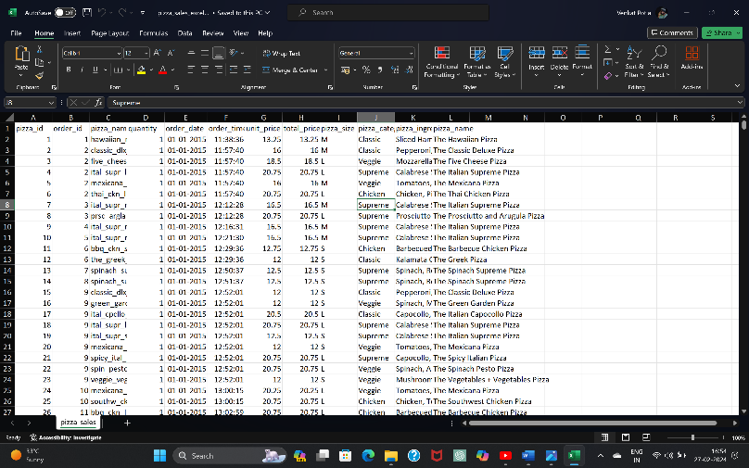

**2.Importing Data set Into MYSQL Database**

* For Importing Dataset into MYSQL Database first We Need To create A New Database

Syntax: Create Database Database_name;

Create Database Pizza_DB;

* For Import the Dataset Into The Database Right click on Database Name Go To Table Data Import Wizard Then Choose file What We want To Import Into Database.
* After successful Import The Data Will Shows In the Form Of Table. We Can Retrieve The Table Data By Writing Queries.

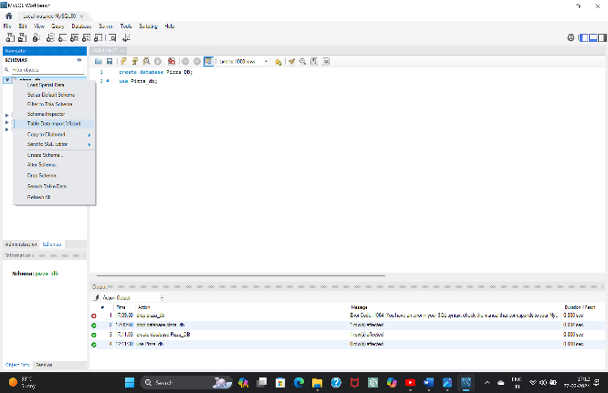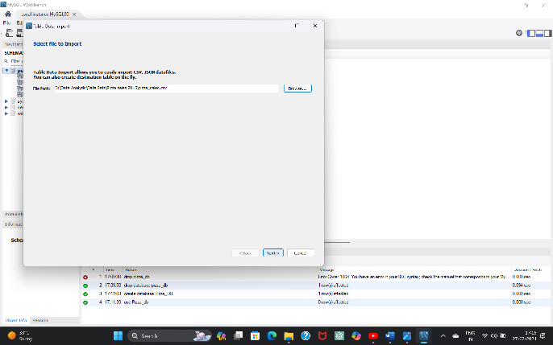

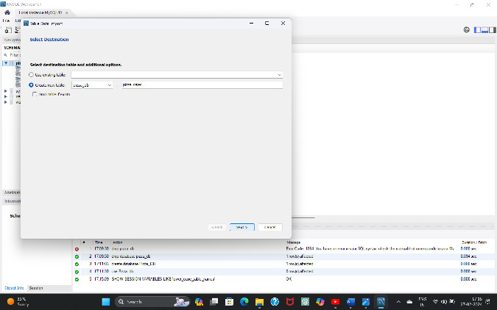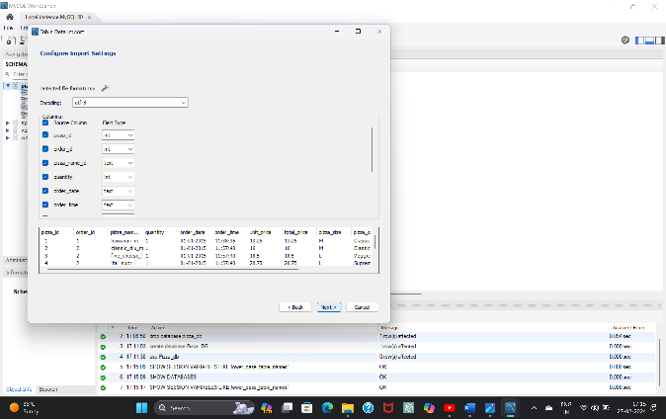

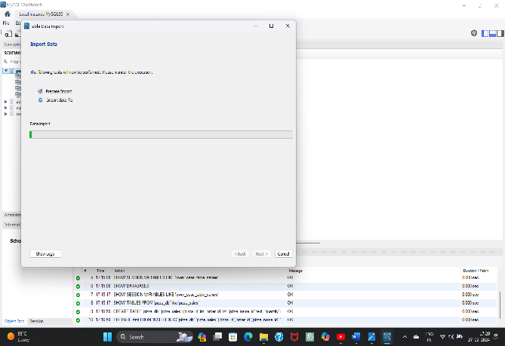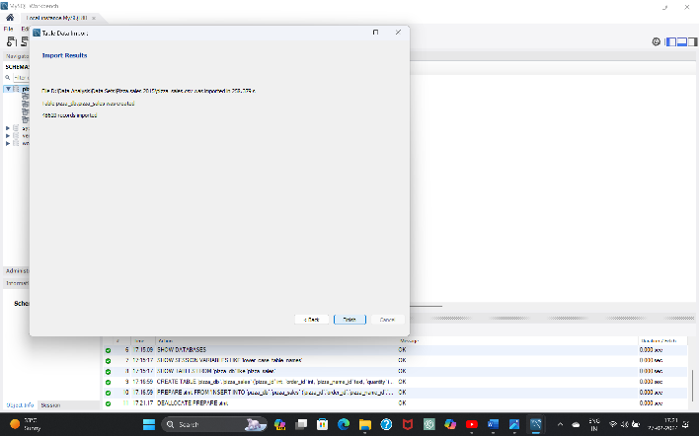

* After Import Retrieve The table date By Writing DQL Command

Syntax: Select * From Table_name;

Select * From Pizza_sales;

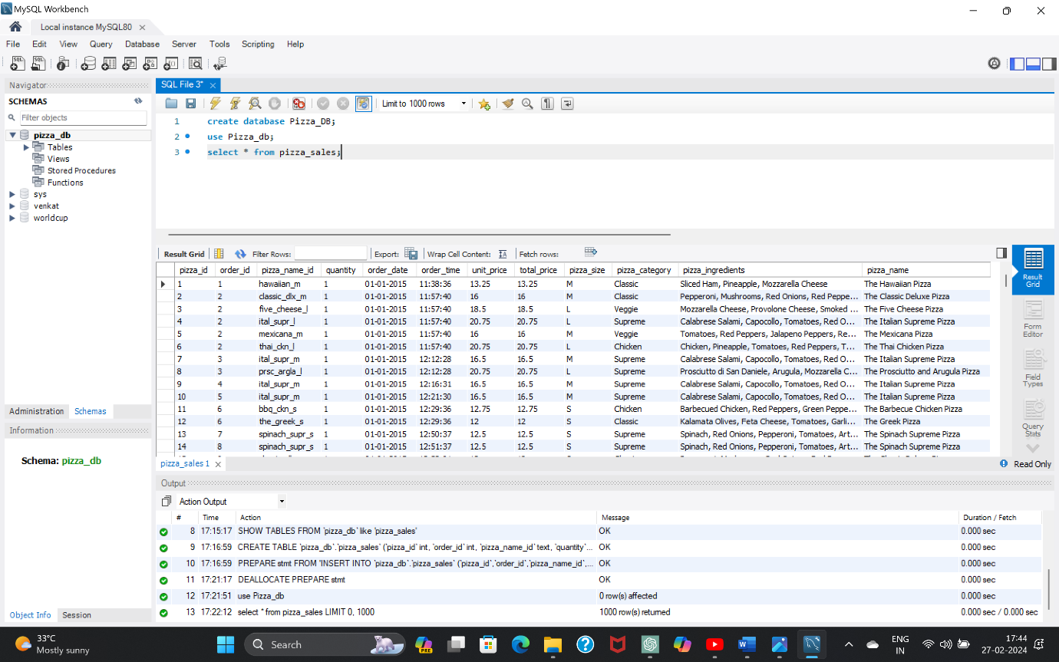

**3.writing The Queries To Evaluate The Values**

**Here I’m Writing SQL Queries Based On the Requirements To Evaluate The Values With Dashboards.**

1. **Total Revenue**

**select sum(total_price) as Total_Revenue From Pizza_sales;**

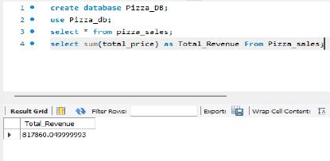

1. **Average Order Value**

**select sum(total_price)/count(distinct order_id) as Avg_Order_vaule From pizza_sales;**

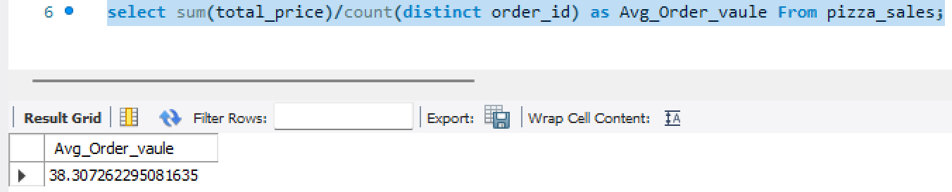

1. **Total Pizza Sold**

**select sum(quantity) as Total_pizza_sold from pizza_sales;**

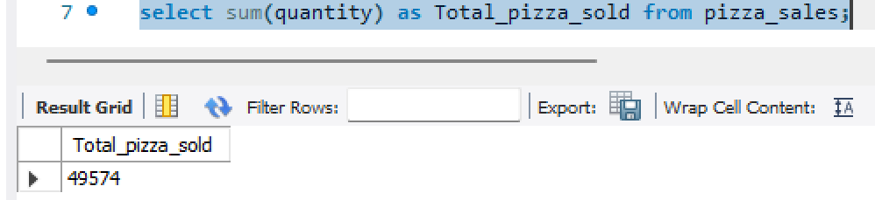

1. **Total Orders**

**select count(distinct order_id) as Total_Orders from pizza_sales;**

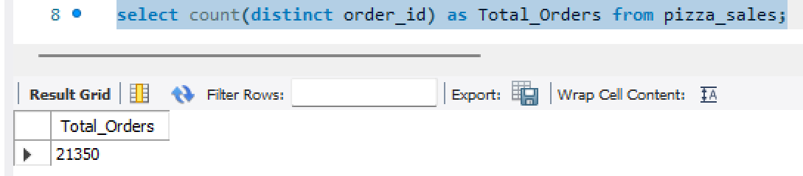

1. **Average Pizza Per Order**

**select cast(sum(quantity) as decimal(10,2)) / cast(count(distinct order_id) as decimal(10,2)) as Avg_pizza_per_order from pizza_sales;**

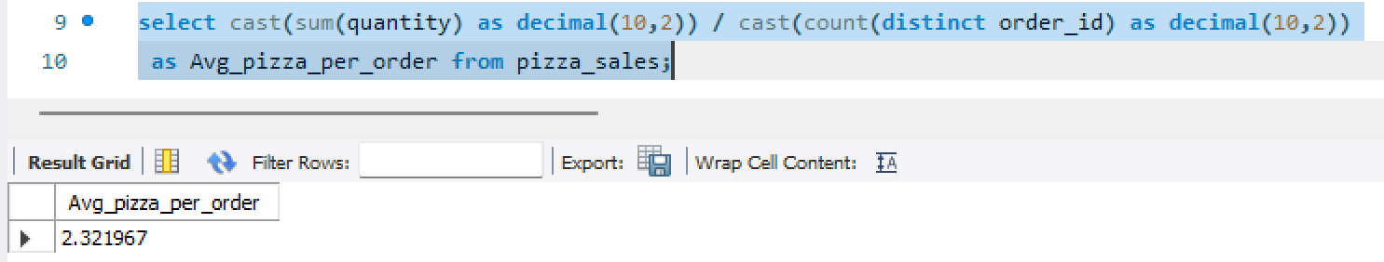

1. **Daily Trend For Total Orders**

**select dayname(order_date) as Order_day,count(distinct order_id) as Total_orders from pizza_sales group by dayname(order_date);**

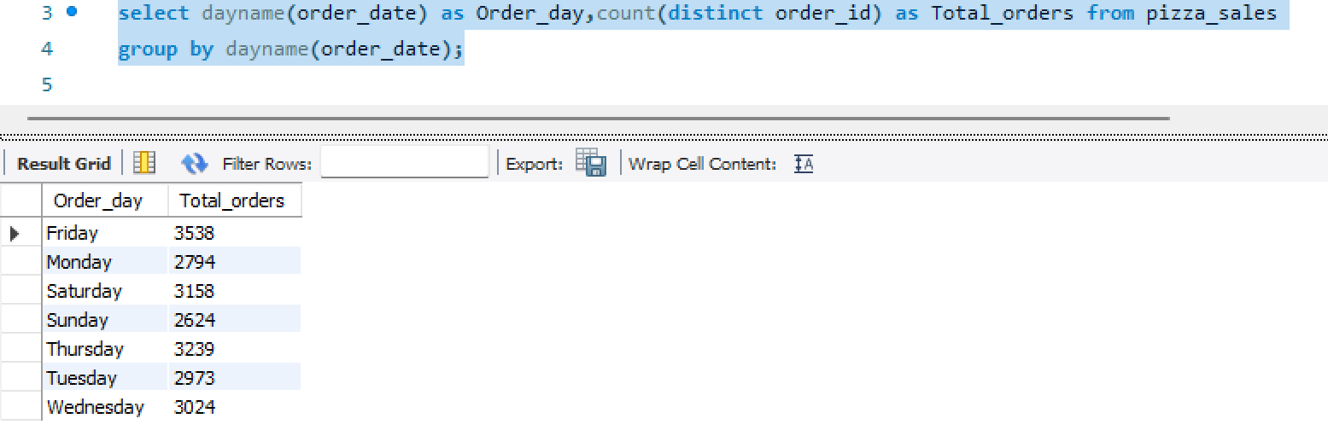

1. **Monthly Trend For Total Orders**

**select monthname(order_date) as Month_Name,count(distinct order_id) as Total_orders from pizza_sales group by monthname(order_date);**

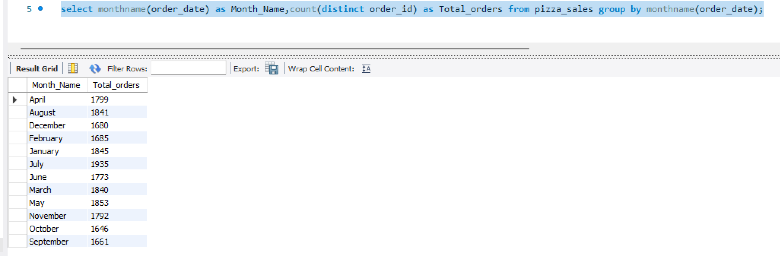

1. **Percentage of sales By Pizza category**

**select pizza_category,sum(total_price) *100 / (select sum(total_price) from pizza_sales) as Totalcategory_percentage from pizza_sales group by pizza_category;**

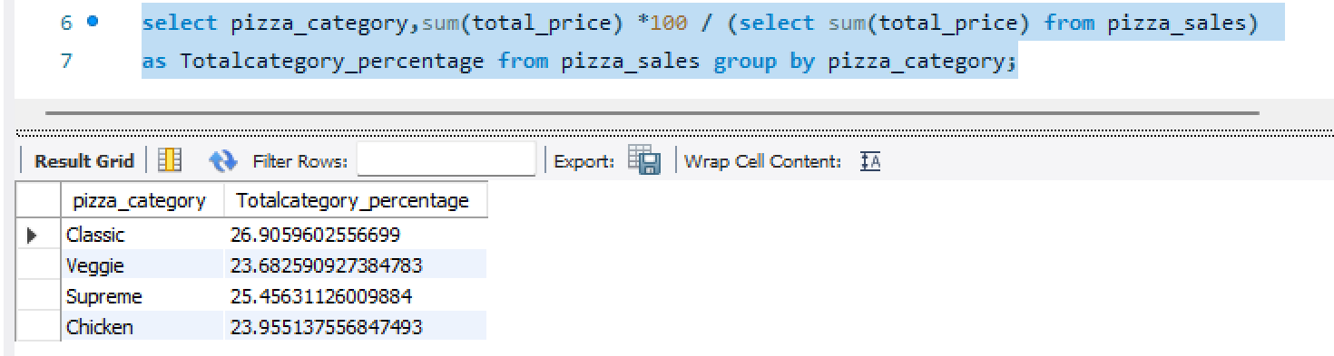

**select pizza_category,sum(total_price) as Total_Revenue,sum(total_price) *100 / (select sum(total_price) from pizza_sales where month(order_date) in (1,2,3,4)) as Totalcategory_percentage from pizza_sales where month(order_date) in (1,2,3,4) group by pizza_category;**

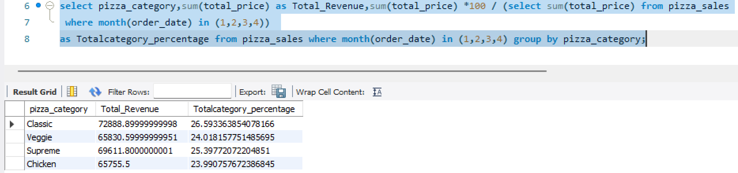

1. **Percentage of sales By Pizza Size**

**select pizza_size,sum(total_price) as Total_Revenue,sum(total_price) *100 / (select sum(total_price) from pizza_sales) as Totalcategory_percentage from pizza_sales group by pizza_size;**

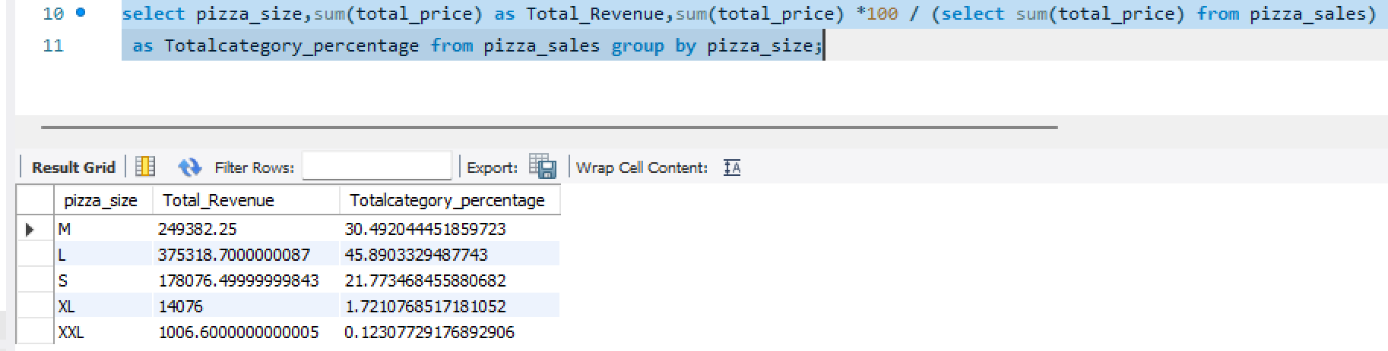

1. **Total Pizza Sold By Pizza category**

**select pizza_category,count(distinct order_id) as Totalpizza_sold from pizza_sales group by pizza_category;**

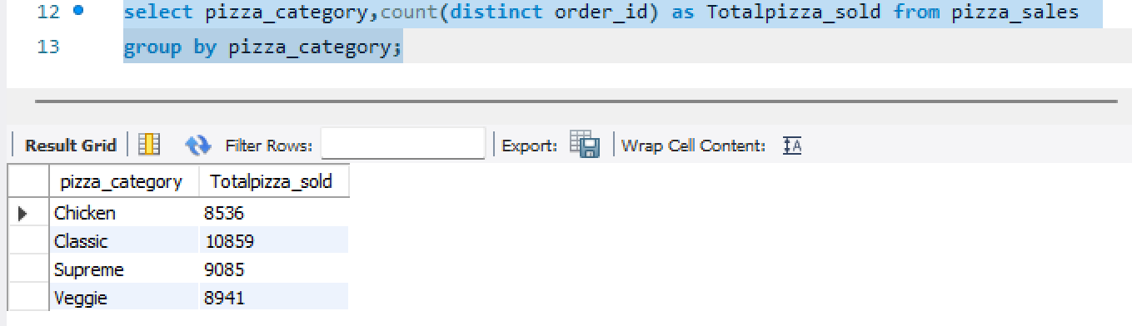

1. **Top 5 Best Seller’s By Revenue, Total Quantity and Total Order’s**

**select pizza_name,sum(total_price) as Total_Revenue from pizza_sales group by Pizza_name order by Total_Revenue desc limit 5;**

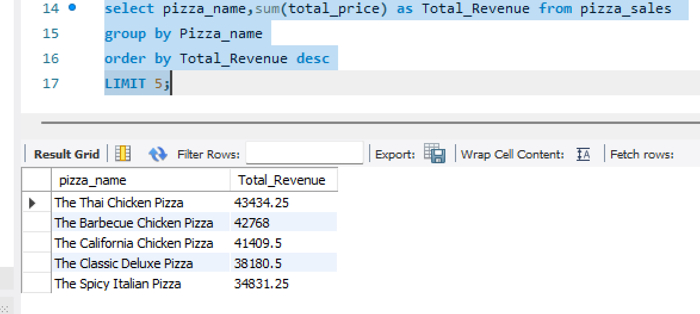

**select pizza_name,sum(quantity) as Total_Quantity from pizza_sales group by Pizza_name order by Total_Quantity desc limit 5;**

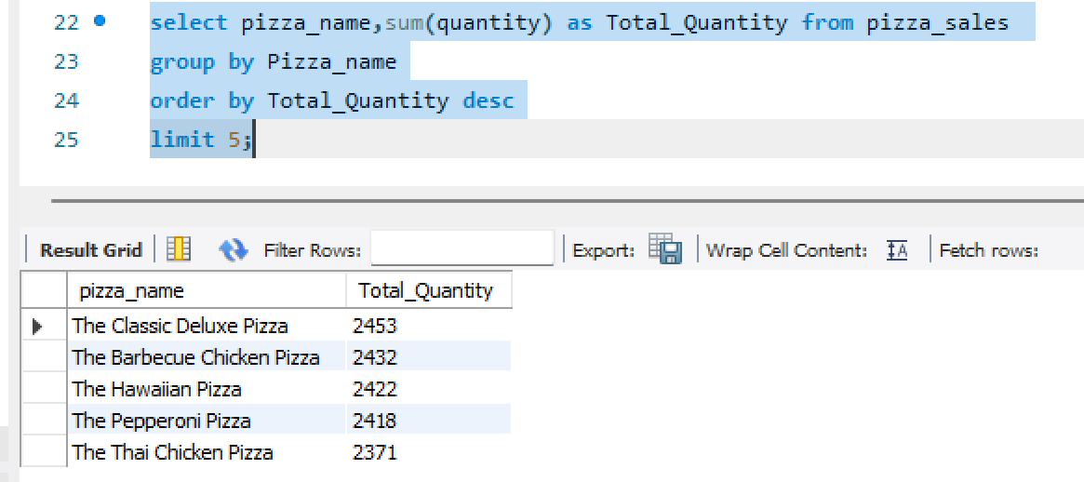

**select pizza_name,count(distinct order_id) as Total_orders from pizza_sales group by Pizza_name order by Total_orders desc limit 5;**

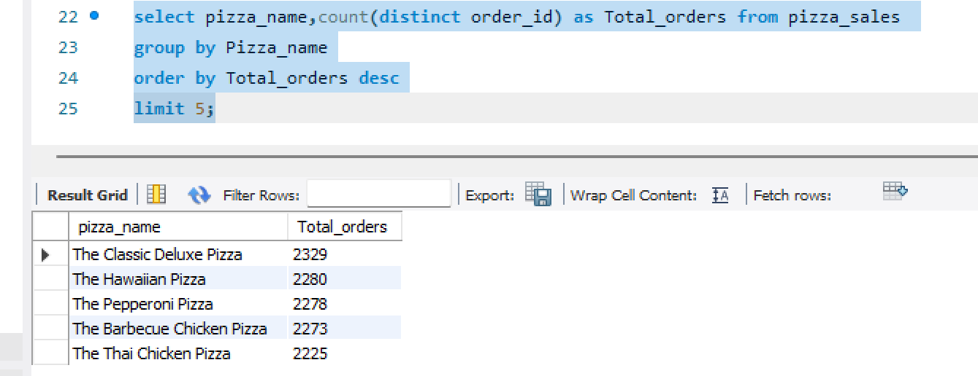

1. **Bottom 5 Worst Seller’s By Revenue, Total Quantity and Total Order’s**

**select pizza_name,sum(total_price) as Total_Revenue from pizza_sales group by Pizza_name order by Total_Revenue asc limit 5;**

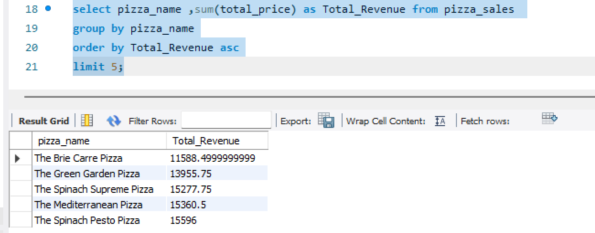

**select pizza_name,sum(quantity) as Total_Quantity from pizza_sales group by Pizza_name order by Total_Quantity asc limit 5;**

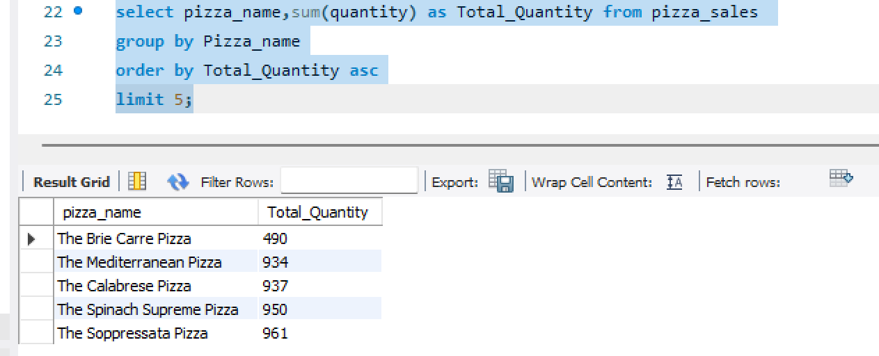

**select pizza_name,count(distinct order_id) as Total_orders from pizza_sales group by Pizza_name order by Total_orders asc limit 5;**

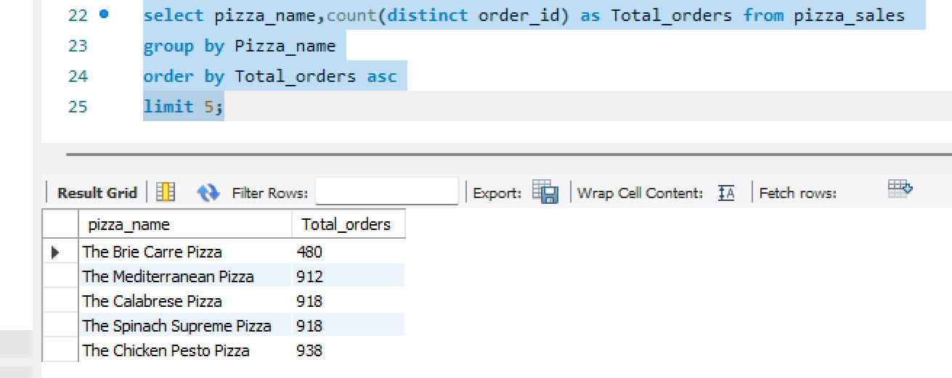

**4.Creating Report For MYSQL Server**

Now Save All The Queries which We are Wrote For Evaluate the Values With The Dashboards. Create Report For MYSQL Queries

**5.Connect MYSQL Server With Power BI**

* For That Open Power BI Go to Get Data and Select MYSQL Database Then Make a Connection With MYSQL Database

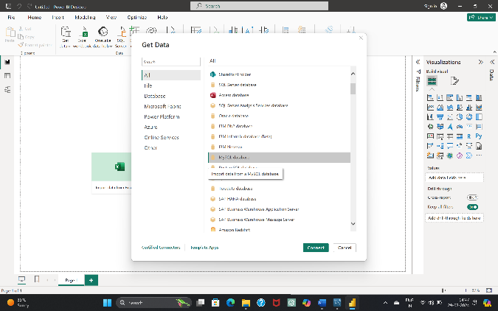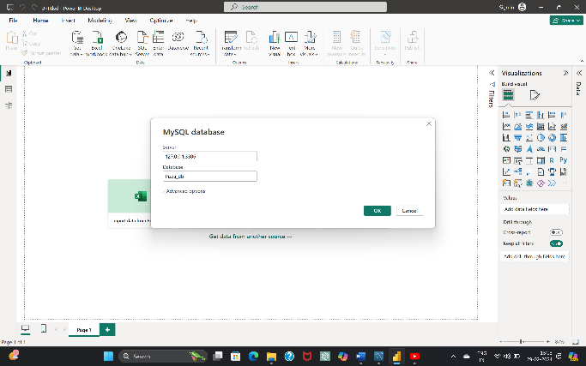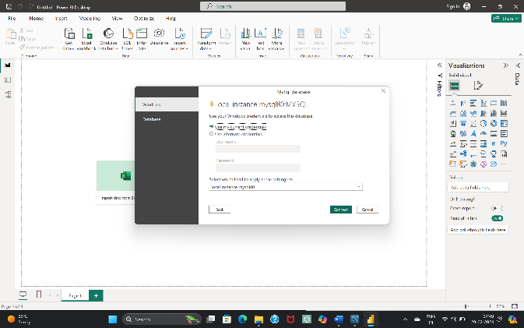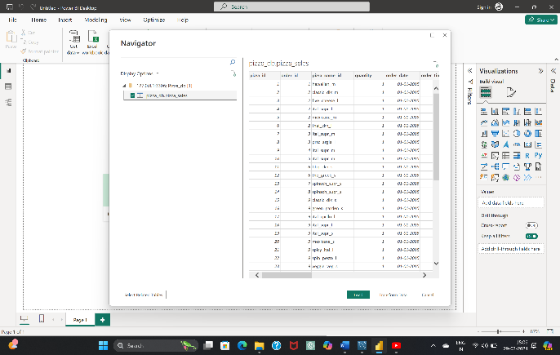

* After Completion of Connection we can Load Or Transform Data Based On Requirement

**6.Data Cleaning &Processing**

* After Data Loading Into PowerBI By Using The Power Query Editor We Perform DAX(Data Analysis Express) For Data cleaning and Processing
* This Are Some Of DAX Formulas written for Data Visualization

1. Total Orders = DISTINCTCOUNT('pizza_db pizza_sales'[order_id])
2. Total Pizza Sold = sum('pizza_db pizza_sales'[quantity])
3. Total Revenue = sum('pizza_db pizza_sales'[total_price])
4. Avg Pizzas Per Order = [Total Pizza Sold]/[Total Orders]
5. Avg Order Value = [Total Revenue]/[Total Orders]
6. Order Day = upper(LEFT('pizza_db pizza_sales'[Day Name],3))
7. Order Month = upper(LEFT('pizza_db pizza_sales'[Month Name],3))

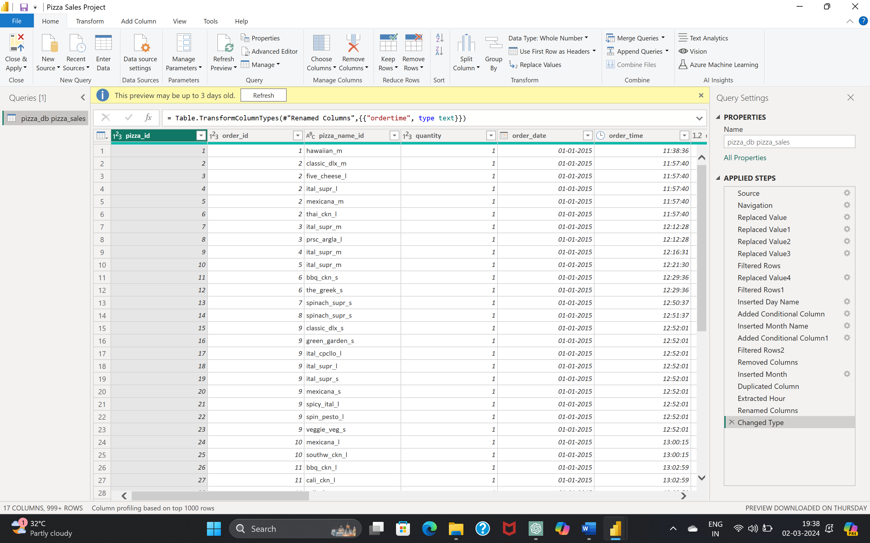

**8.Data Visualization**

* After Data Cleaning And Data Processing Based On The Requirements of Business Stakeholders Prepare Dashboards’ For a Pizza Business To Gain Insights And Improve Decision-Making

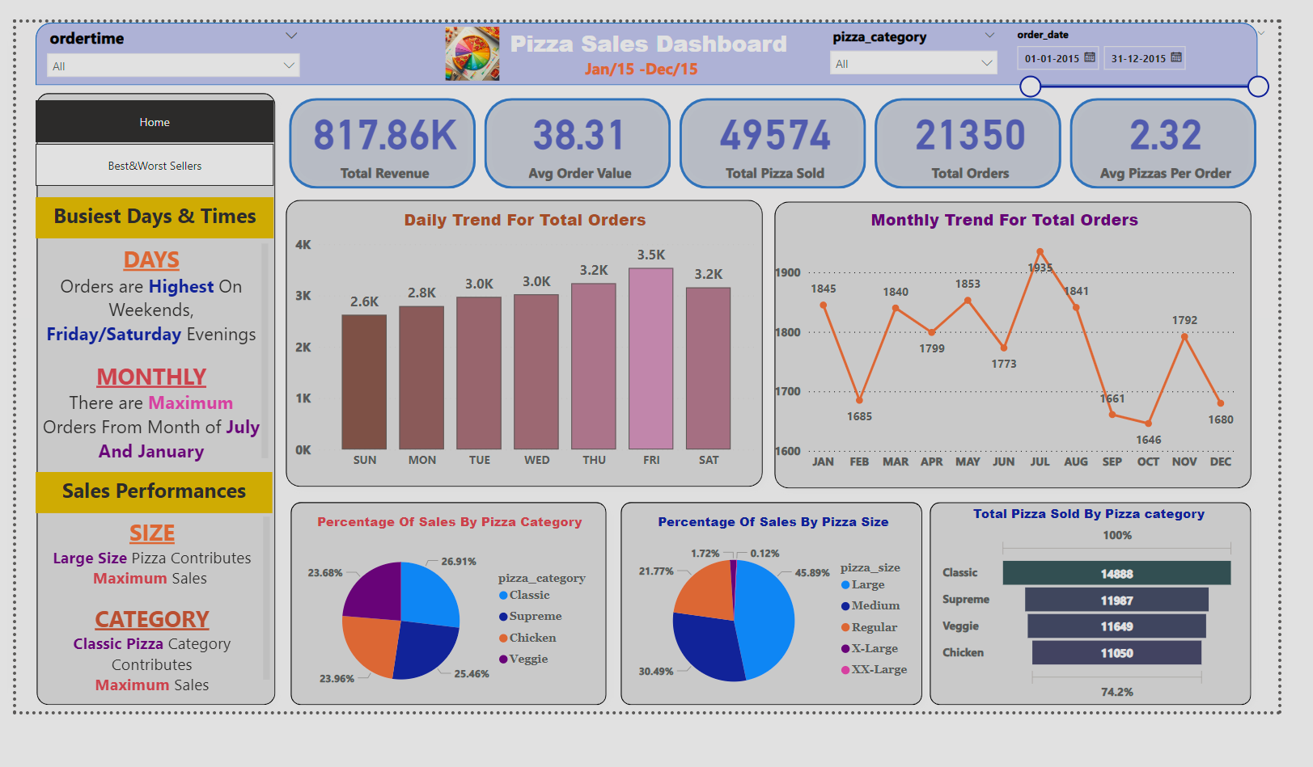

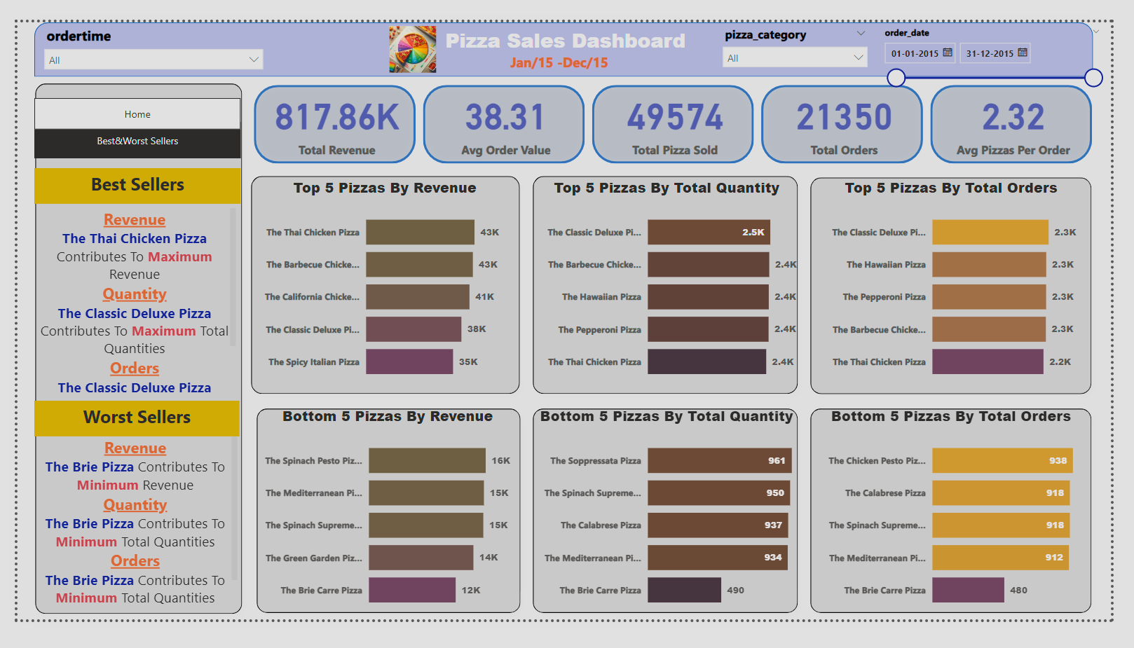

### **Conclusion:**

**Overall Performance:**

* + - The pizza sales data reveals a total revenue of **817.86K** with an average order value of **38.31**. This indicates a healthy financial performance.
    - A total of **49,574 pizzas** were sold, resulting in **21,350 orders**. On average, each order contains **2.32 pizzas**.
    - The Thai Chicken Pizza is the highest revenue-generating item, contributing significantly to the total revenue of **817.86K**.
    - The Classic Deluxe Pizza is popular in terms of quantity sold and total orders placed
* On average, each order contains approximately **2.32 pizzas**.

**Busiest Days and Times:**

* **Weekends**, particularly **Friday and Saturday evenings**, witness the highest order volumes. It’s crucial to allocate resources effectively during these peak hours.
* The months of **July and January** consistently show the maximum number of orders. Seasonal trends should be considered for inventory planning.

**Sales Performances:**

* **Large size pizzas** contribute significantly to overall sales. Focusing on promoting this category could yield further growth.
* The **classic pizza** category also plays a substantial role in sales.